INDUSTRY WHITEPAPER

The Architectural Divide
A Multi-Dimensional Analysis of Traditional vs. Low-Code Development
Author: Akshat Singh, 241401008
Enterprise Architecture & Technology Strategy Series

1 — Macroeconomic Context & The Evolution of Software Engineering

1.1 Executive Summary
Enterprises today face a structural contradiction: boards and executive committees are demanding digital transformation at a velocity that has never been higher, while the global supply of specialized, senior software engineering talent has never been scarcer relative to demand. This is not a temporary staffing shortfall; it is a persistent, structural mismatch between the rate at which business logic must be encoded into software and the rate at which qualified engineers can be hired, onboarded, and retained. Into this gap has stepped low-code development — not merely as a productivity tool or a stopgap measure, but as a genuine paradigm shift in how organizations conceive of the relationship between business intent and executable software. This whitepaper examines that shift from first principles: the engineering mechanics beneath both approaches, the financial structures that govern their total cost of ownership, the security and governance frameworks each requires, and the organizational psychology of who is empowered to build.

1.2 The Software Crisis & Velocity Bottlenecks
Traditional software delivery, however well-managed, is fundamentally serial: requirements are gathered, specifications are written, code is built, and only then is functionality validated against the original business need. In large enterprises, this creates a velocity bottleneck at the interface between business stakeholders and IT departments. Business units understand the problem in the language of process and outcome; engineering teams must translate that language into data models, APIs, and application logic before anything can be tested. Each translation cycle introduces latency, and each misunderstanding compounds into rework. As digital initiatives multiply across every business function — finance, HR, supply chain, customer service — the finite capacity of centralized engineering teams becomes the single greatest constraint on enterprise agility, producing backlogs measured in quarters rather than weeks.

1.3 The Abstraction History
Software engineering has always progressed by adding layers of abstraction between human intent and machine execution. Assembly language gave way to procedural and compiled languages such as C, which traded some low-level control for portability and readability. The rise of managed, object-oriented and interpreted languages — Java, Python, and their contemporaries — abstracted memory management and platform specifics further still, allowing engineers to reason primarily in terms of business objects and application logic. Low-code represents the next rung on this same ladder: it abstracts not just the machine, but the syntax itself, replacing textual code with visual metadata that a runtime engine interprets and compiles. This is a continuation of software history, not a departure from it.
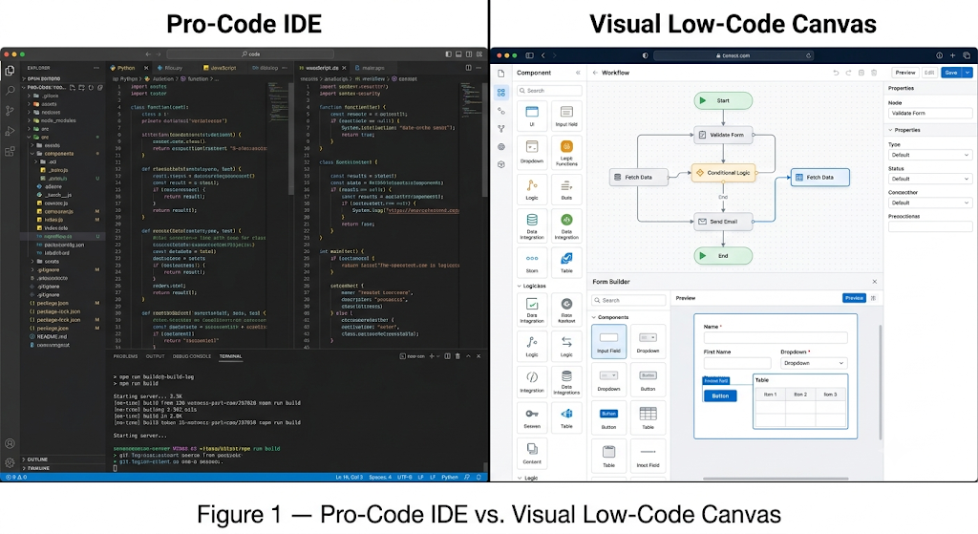
Figure 1. Conceptual comparison of a traditional code-centric development environment (left) against a modern visual, metadata-driven low-code canvas (right).

2 — Deep Dive into Traditional "Pro-Code" Architecture & Mechanics

2.1 The Pro-Code Stack & SDLC
Traditional, hand-written software engineering demands mastery across a deep and unforgiving technical stack. At the application layer, engineers must manage memory allocation and lifecycle (or, in managed runtimes, understand garbage-collection behavior well enough to avoid leaks and latency spikes). At the data layer, teams perform manual database schema migrations, carefully versioning structural changes to avoid data loss or downtime in production systems. At the integration layer, engineers implement API security protocols such as OAuth 2.0 and OpenID Connect (OIDC) to govern authentication and authorization between services. Delivery itself is industrialized through CI/CD pipelines built on tools such as GitHub Actions or Jenkins, and applications are packaged and orchestrated using containerization technologies such as Docker and Kubernetes. Each of these disciplines is itself a specialization, and enterprise-grade software typically requires competence in all of them simultaneously.

2.2 Uncompromising Advantages
Despite — or rather because of — this complexity, traditional coding retains categorical advantages that no abstraction layer has yet replicated:
- Absolute architectural freedom — engineers may design any data model, algorithm, or system topology the problem demands, unconstrained by a vendor's object model.
- Low-level execution speed optimization — direct control over memory, threading, and I/O allows performance tuning impossible in an abstracted runtime.
- Algorithmic complexity handling — computationally intensive logic (real-time analytics, custom machine learning pipelines, high-frequency processing) can be implemented precisely as specified.
- Total intellectual property ownership — the resulting codebase belongs entirely to the organization, with zero platform dependency and no licensing entanglement.

2.3 The True Cost of Tailored Code
The advantages above are counterbalanced by a well-documented and often underestimated liability: technical debt. Every custom codebase begins to accrue debt the moment engineers choose expedience over ideal design — a reasonable and often necessary trade-off under deadline pressure. Over years of iteration, however, these shortcuts compound. Dependencies age past their supported lifecycles, original architects leave the organization, and documentation drifts out of sync with the actual system. The result is a codebase that becomes progressively more brittle: each new feature requires disproportionate effort to implement safely, and each patch carries elevated risk of unintended regression.
Technical debt is not a one-time cost but a recurring tax on every future change. Enterprises routinely underestimate that the ongoing burden of legacy maintenance, refactoring, and dependency patching can, over a system's lifetime, exceed the cost of its original construction.
Legacy system maintenance therefore becomes a distinct budget line in its own right — encompassing security patching, framework version upgrades, and the retraining or backfilling of institutional knowledge as engineers rotate off long-lived projects. Left unmanaged, this operational burden crowds out capacity for genuine innovation, as engineering teams spend an increasing share of their time simply keeping existing systems stable rather than building new capability.

3 — The Mechanics, Guardrails, and Risks of Low-Code Platforms

3.1 Metadata-Driven Architecture
It is a common misconception that low-code platforms eliminate code entirely. In reality, low-code operates on a metadata-driven architecture: a visual designer captures the developer's intent — data models, business rules, screen layouts, process flows — as structured metadata rather than as hand-written syntax. A core platform engine interprets or compiles this metadata into standard, compliant code (commonly Java, JavaScript, or SQL) at build time or runtime, and that generated code executes on conventional application servers and databases exactly as hand-written code would.
Critically, mature platforms provide a “trapdoor” mechanism: a deliberate escape hatch through which professional developers can inject custom JavaScript, Python, or raw SQL directly into the generated logic. This trapdoor is what allows low-code to flex beyond its visual defaults when a business requirement exceeds what drag-and-drop configuration can express, without forcing a wholesale migration back to a pro-code project.

3.2 The Rise of the Citizen Developer
The organizational consequence of metadata-driven development is the emergence of the citizen developer: a business analyst, operations manager, or subject-matter expert who, without formal engineering training, can assemble functional applications directly from their own domain knowledge. This has a measurable psychological effect within organizations — it shortens the distance between having an idea and seeing it run, which increases engagement and ownership among business teams that were previously reduced to submitting tickets and waiting. Practically, it also relieves centralized IT backlogs, freeing professional engineers to focus on high-complexity, high-value systems while routine internal tooling is built closer to the business problem it serves.

3.3 The Enterprise Risks (Security, Lock-in, & Shadow IT)
This democratization carries real and well-documented risks that any balanced analysis must weigh alongside its benefits:
- Shadow IT — applications built by citizen developers outside formal IT governance can proliferate unmonitored, creating compliance blind spots and inconsistent data handling.
- Platform-level vulnerability exposure — because thousands of tenant applications share a common runtime, a single exploit at the platform layer can have outsized blast radius.
- Vendor lock-in — applications are frequently expressed in a proprietary runtime format that cannot be cleanly exported, making migration to another platform or to pro-code technically and commercially difficult.
- Scaling licensing risk — per-seat or per-application subscription models that appear inexpensive at pilot scale can become a significant, compounding cost center as adoption spreads across the enterprise.
Figure 2 below situates these mechanics within a complete reference architecture, tracing how a request moves upward from the cloud infrastructure and database layer, through the platform engine, its metadata repository, and pre-built API connectors, to the rendered visual application — spanning desktop and mobile — that end users ultimately interact with. Security and authentication are enforced consistently at the platform layer rather than being re-implemented within each individual application.
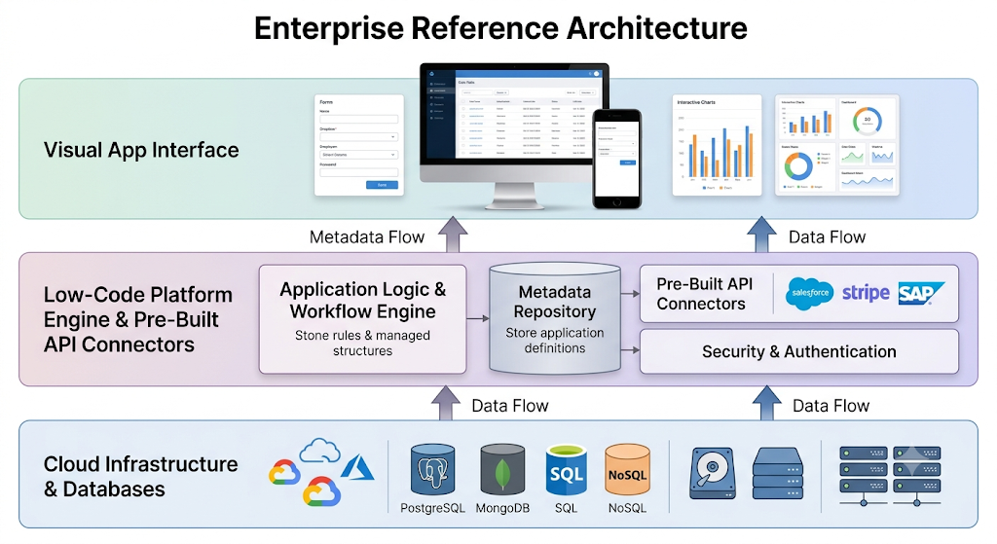
Figure 2. Reference three-tier architecture of a typical enterprise low-code platform, from infrastructure to rendered visual application.

4 — Head-to-Head Comparative Matrix & Financial Total Cost of Ownership

4.1 Multi-Dimensional Evaluation Matrix
The following matrix evaluates both approaches across ten parameters that enterprise architects and finance leaders most commonly weigh during a build decision:
Evaluation Parameter | Traditional (Pro-Code) | Low-Code Platform
Target Audience | Professional software engineers, computer scientists | Business analysts, ops managers, “citizen developers”
Time-to-Market | Weeks to months for production-grade features | Days to weeks for functional prototypes and internal apps
Skill Cap / Learning Curve | Steep; requires formal training in languages, architecture, and DevOps | Shallow entry, but a hidden ceiling once logic exceeds visual capacity
Upfront Capital Cost | High — salaried engineering teams and infrastructure build-out | Low — subscription onboarding with minimal hiring
Long-Term Scaling Cost | Marginal cost per user/transaction stays low once built | Compounding — per-seat or per-workflow licensing scales with adoption
Customization Boundaries | Unlimited; constrained only by engineering time | Bounded by the platform’s object model and exposed APIs
Integration Agility | Fully bespoke integrations, but each must be engineered | Rapid via pre-built connectors, shallow for non-standard systems
Security Governance | Fully auditable; security posture is the organization’s own responsibility | Inherits vendor’s controls; visibility into internals is limited
DevOps Overhead | Substantial — pipelines, containers, orchestration, monitoring | Minimal — largely abstracted away by the platform vendor
Vendor Dependency | None; full ownership of source and runtime | High — proprietary runtime creates exit and migration friction

4.2 Financial Engineering (CapEx vs. OpEx)
The two approaches map onto fundamentally different financial structures. Traditional coding is a high Capital Expenditure (CapEx), low Operational Expenditure (OpEx) model: the organization pays a large upfront cost to hire or contract engineering teams and build infrastructure, but once the system is stable, the marginal cost of running it at scale — additional users, additional transactions — remains comparatively low. Low-code inverts this profile: it is a low CapEx, high and compounding OpEx model. Onboarding is inexpensive and fast, but subscription fees, per-seat licensing, and platform consumption charges recur indefinitely and typically scale directly with organizational adoption.
There exists a financial inflection point beyond which a low-code platform's compounding subscription costs, extrapolated over a five-to-seven-year horizon at enterprise scale, can exceed what an equivalent traditional build would have cost outright — a calculation finance leaders should model explicitly before scaling any low-code initiative enterprise-wide.
Identifying this inflection point requires modeling license growth against expected user and application counts over the full expected lifetime of the system, not merely against the pilot budget. Enterprises that treat low-code purely as a source of near-term CapEx relief — without projecting its long-run OpEx trajectory — frequently find the calculus of their build decision reversing several years into the platform's life.

5 — The Strategic Decision Framework & The Hybrid Future

5.1 Actionable Selection Criteria
Choose Traditional Coding when:
- The application embodies core intellectual property or a proprietary competitive differentiator.
- The workload involves high-frequency data processing, real-time systems, or computationally intensive algorithms.
- The product requires a unique, highly polished consumer-facing user experience not achievable within a platform's design system.
- Long-term ownership, portability, and freedom from vendor dependency are strategic priorities.
Choose Low-Code when:
- The need is an internal CRUD (create-read-update-delete) tool for operational or administrative use.
- Speed of validation matters more than architectural purity — for example, rapid MVP testing of a new business hypothesis.
- The goal is automating a legacy spreadsheet-based or manual paper workflow with modest complexity.
- The requesting team lacks dedicated engineering capacity and the application's risk profile is low.
Figure 3. Strategic positioning of traditional and low-code approaches by required delivery velocity and application complexity.

5.2 The Hybrid Paradigm (The Composable Enterprise)
The most mature enterprises are converging on neither pole but on a composable, hybrid model. In this pattern, professional developers build robust, well-tested microservices and custom APIs that encapsulate an organization's true intellectual property, performance-critical logic, and system-of-record integrations. These services are then deliberately exposed as secure, governed building blocks within a low-code platform, where business teams assemble them, drag-and-drop style, into applications tailored to their own workflows — without ever touching or compromising the underlying service. This division of labor lets engineering focus its scarce, specialized capacity where it creates the most defensible value, while distributing UI-and-workflow assembly to the teams closest to the problem, under governance the platform enforces by design rather than by policy alone.

5.3 Conclusion
The choice between traditional and low-code development is not a contest with a single winner; it is a portfolio decision that mirrors the diversity of problems any enterprise must solve. Traditional coding remains, and will remain, the only responsible choice for core differentiators, computationally demanding systems, and IP the organization must fully own. Low-code is not a lesser substitute but a genuine architectural category — one built on real computer science, with its own guardrails, risks, and disciplined use cases. The organizations that will out-execute their peers are not the ones that pick a side, but the ones that build the governance maturity to deploy each approach precisely where it belongs, treating the divide between them not as a wall but as a spectrum to be actively engineered.
The future of enterprise software is neither purely hand-written nor purely visual — it is deliberately composed, with governance as the architecture that makes both halves safe to combine.

